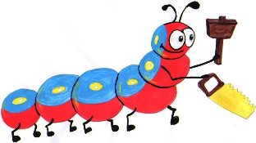

Lyng Primary School Knowledge Organiser

Design Technology

How can recipes be adapted?

Year 5

Topic: DT

Summer

|  |  |
| --- | --- |
| What Goldilocks and Step On words will I use? | |
| **Spelling** | **Defintion** |
| Adaptation | Process of changing something |
| Cross contaminiation | When something harmful spreads from one food to another |
| Hygeine | Keeping things clean to prevent illness |
| Ingredient | The foods a recipe is made from |
| Label | Something that provides information about the prduct it is attached to |
| Nutrient | Substences that help living things to stay healthy and grow |
| Nutritional value | The nutrients a food or recipe provides |



**Design Brief for pupils:**

* Research a traditional recipe and make changes to it
* Add nutritional value to a recipe by selecting ingredients
* Prepare and cook a version of Bolognese sauce

**Purpose:** to adapt a Bolognese sauce to increase its nutritional value

**Audience:** children eating the sauce



|  |
| --- |
| Skills and techniques |
| * Explaining the farm to fork process * Research existing recipes * Suggesting alternative ingredients * Analysing nutritional content * Writing an alternative recipe * Understanding cross contamination * Using preparation skills * Designing a jar label * Making a developed recipe |

Summer Term

**Cooking**

**Children will be taught** that recipes can be adapted to suit nutritional needs and dietary requirements. That nutritional information is found on food packaging. That coloured chopping boards can prevent cross contamination. That food packaging serves many purposes.

**Agreed outcome:**

To follow and make an adapted recipe

**Agreed outcome:**

A length of textile bunting created using children’s individual bunting triangles.